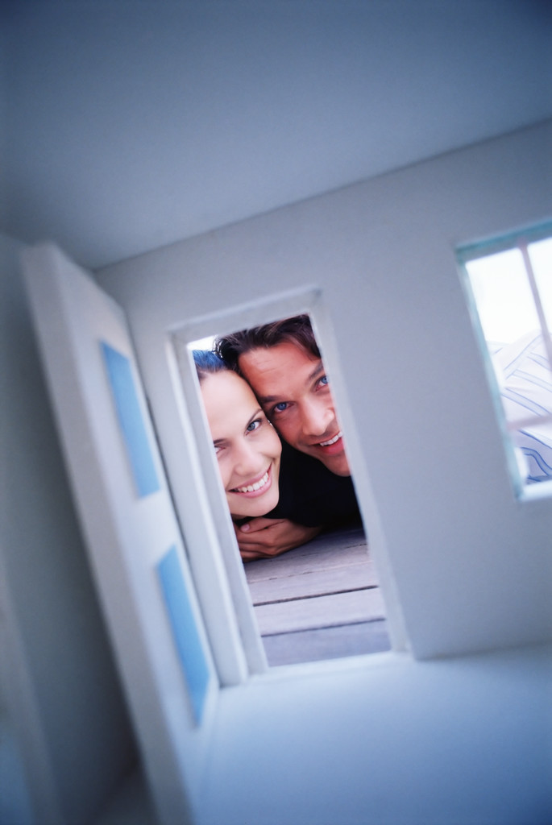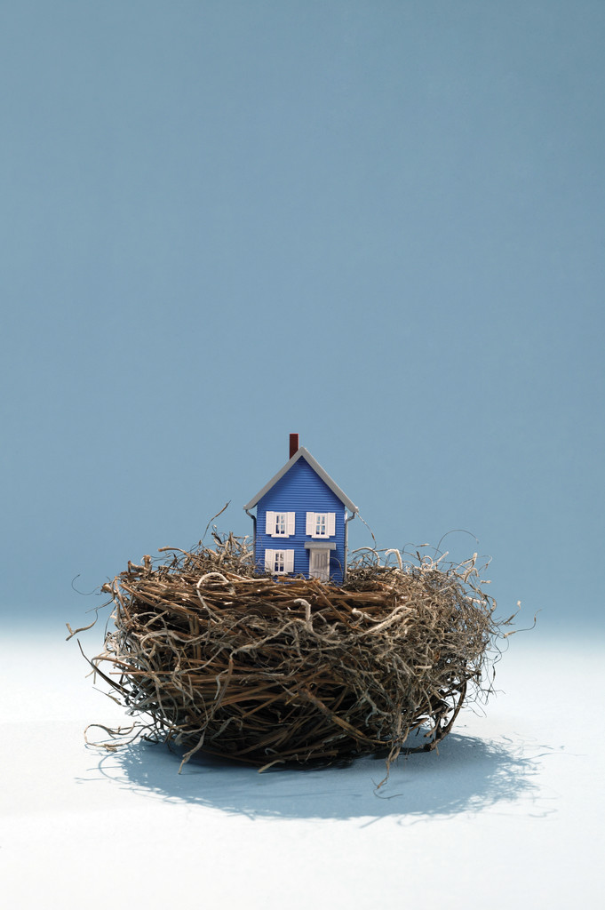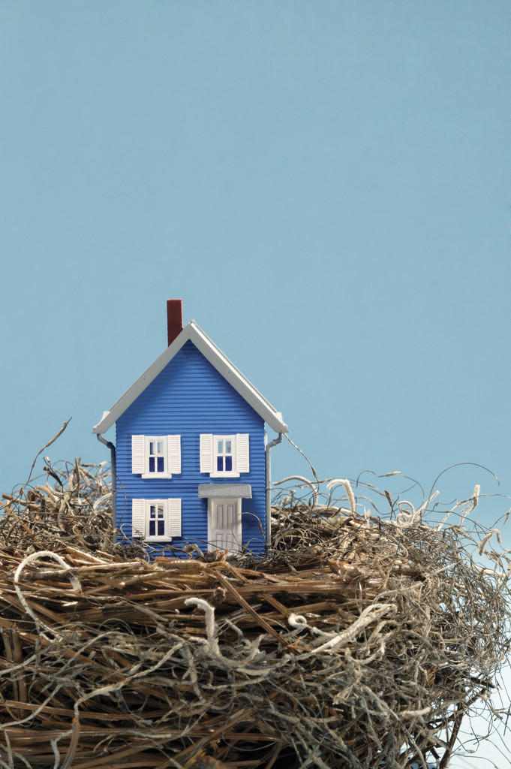

Paragraphs about hours, seasons and best time to go

#### Hours of operation, seasons and best time to visit

# Seasons

### Park address

🙞 🙜

Group members

Park Name

YEAR

🙞 🙜

Year established and by whom (if known)

Paragraph including size and location.

## Location and Size

Listing of things to do or in paragraphs

Paragraphs this will fill both boxes. Begin typing here.

# Important or impressive features

## Things to do